SECTOR AREAS AND ARC LENGTH
Pearson Edexcel – Thursday 4 June 2020 - Paper 2 (Calculator) Higher Tier
1.
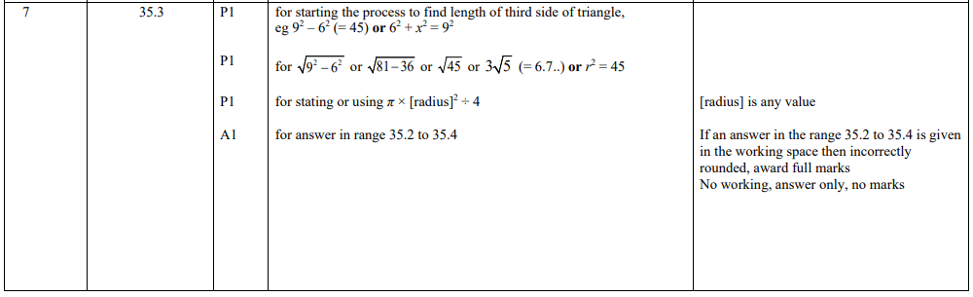
Pearson Edexcel – Thursday 4 June 2020 - Paper 2 (Calculator) Higher Tier
2.
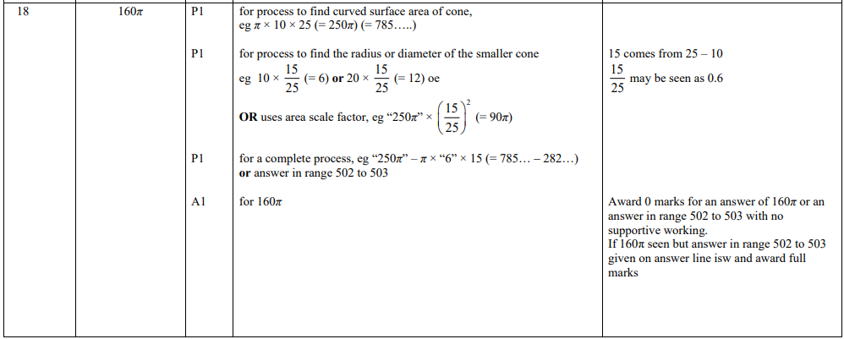
Pearson Edexcel – Monday 8 June 2020 - Paper 3 (Calculator) Higher Tier
3.
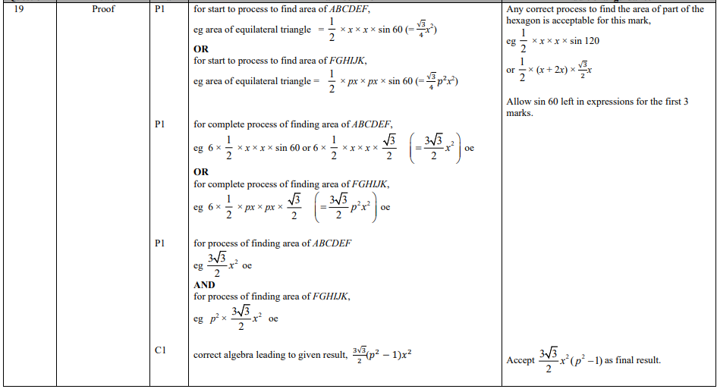
Pearson Edexcel - Thursday 6 June 2019 - Paper 2 (Calculator) Higher Tier
4.
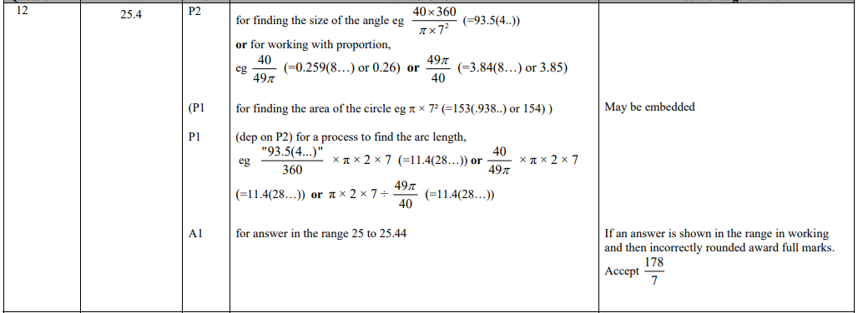
Pearson Edexcel - Tuesday 6 November 2018 - Paper 1 (Non-Calculator) Higher Tier
5.
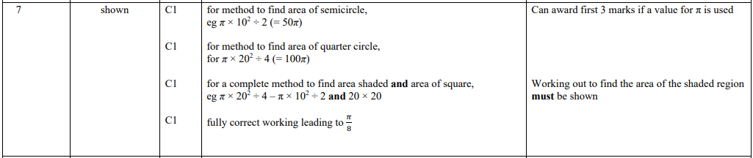
Pearson Edexcel - Thursday 2 November 2017 - Paper 1 (Non-Calculator) Higher Tier
6.
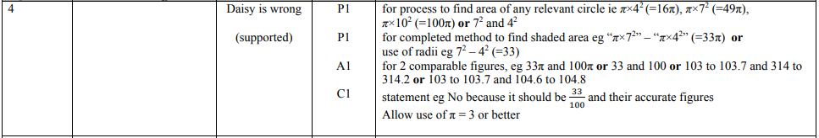
Pearson Edexcel - Monday 6 November 2017 - Paper 2 (Calculator) Higher Tier
7.
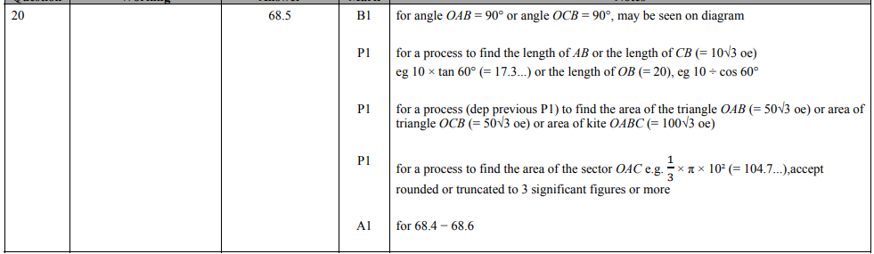
Pearson Edexcel - Thursday 8 June 2017 - Paper 2 (Calculator) Higher Tier
8.
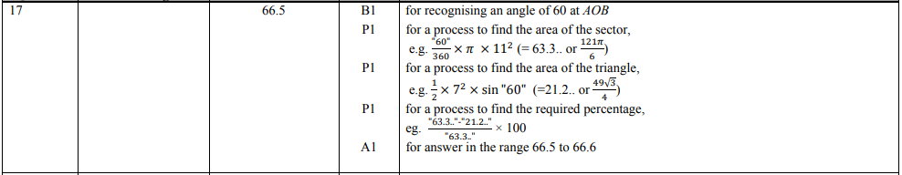
Pearson Edexcel - Tuesday 13 June 2017 - Paper 3 (Calculator) Higher Tier
9.
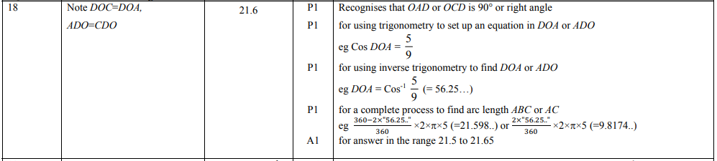

Pearson Edexcel - Specimen Papers Set 2 - Paper 1 (Non-Calculator) Higher Tier
10.
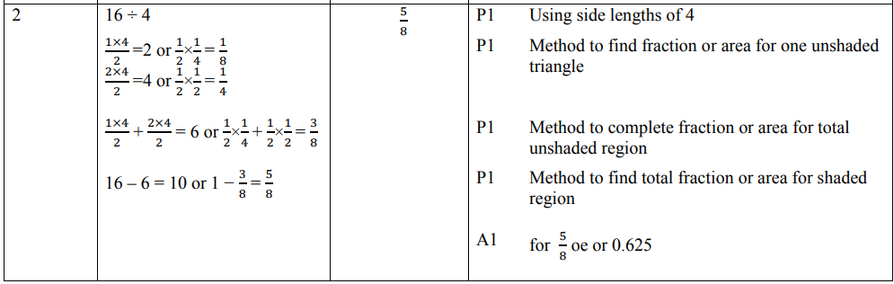
Pearson Edexcel - Specimen Papers Set 2 - Paper 2 (Calculator) Higher Tier
11.
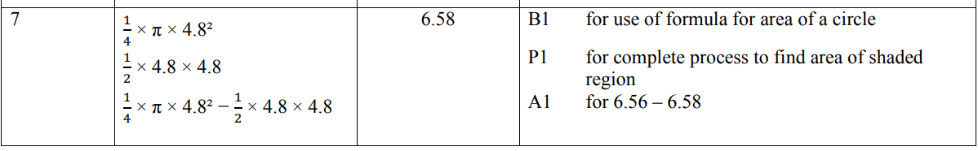
Pearson Edexcel - Specimen Papers Set 2 - Paper 3 (Calculator) Higher Tier
12.
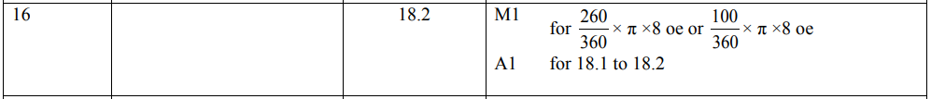
Pearson Edexcel - Sample Paper 2 - (Calculator) Higher Tier
13.
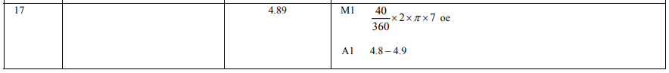
Pearson Edexcel - Sample Paper 3 - (Calculator) Higher Tier
14.
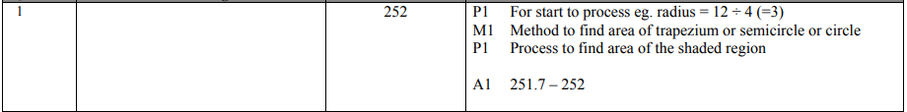
Pearson Edexcel - Thursday 26 May 2016 - Paper 1 (Non-Calculator) Higher Tier
15.
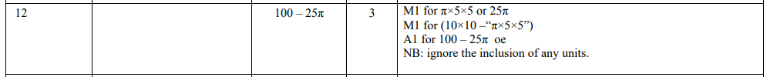
Pearson Edexcel - Thursday 26 May 2016 - Paper 1 (Non-Calculator) Higher Tier
16.
Pearson Edexcel - Wednesday 5 November 2014 - Paper 1 (Non-Calculator) Higher Tier
17.
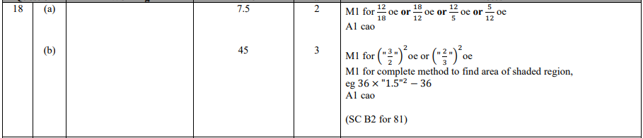
Pearson Edexcel - Monday 4 March 2013 - Paper 2 (Calculator) Higher Tier
18.
Pearson Edexcel - Tuesday 6 November 2012 - Paper 1 (Non-Calculator) Higher Tier
19.
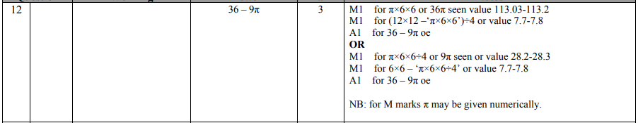
Pearson Edexcel - Friday 2 March 2012 - Paper 3 (Non-Calculator) Higher Tier
20.
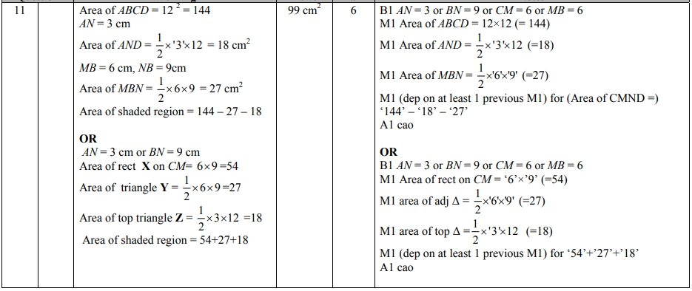
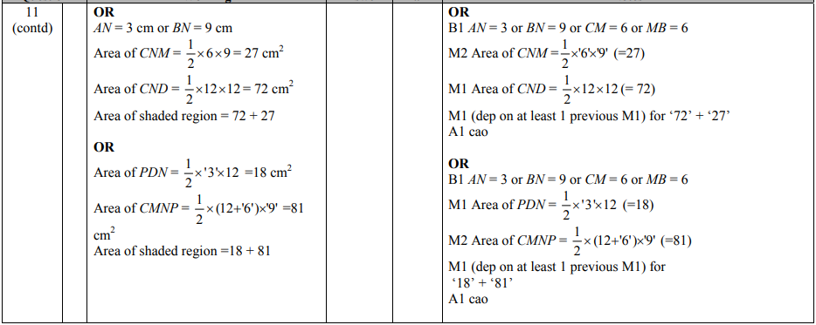
Pearson Edexcel - Monday 5 March 2012 - Paper 4 (Calculator) Higher Tier
21.
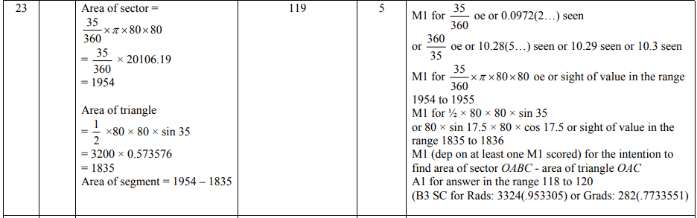
Pearson Edexcel - Friday 10 June 2011 - Paper 4 (Calculator) Higher Tier
22.
Pearson Edexcel - Friday 11 June 2010 - Paper 4 (Calculator) Higher Tier
23.
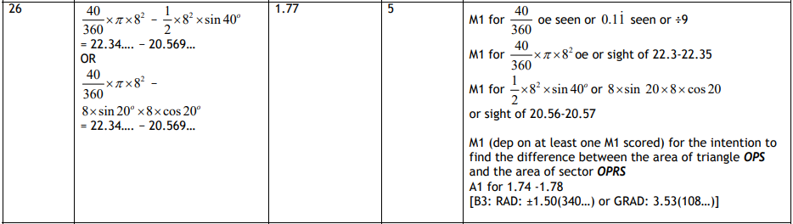
OCR GSCE – Thursday 6 June 2019 – Paper 5 (Non-Calculator) Higher Tier
24.
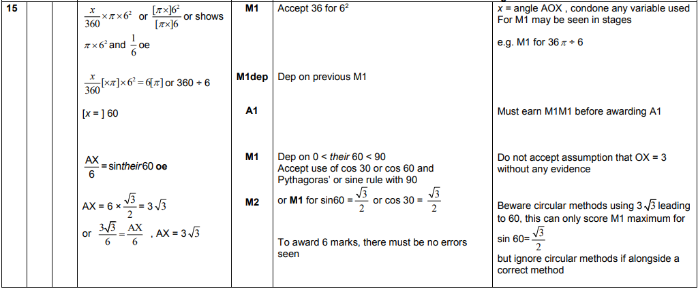

OCR GSCE – Thursday 8 November 2018 – Paper 5 (Non-Calculator) Higher Tier
25.
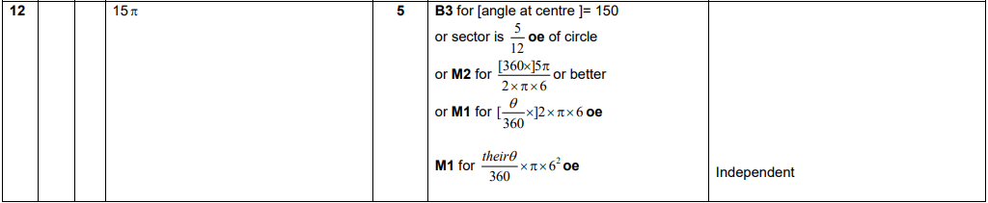
OCR GSCE – Tuesday 6 November 2017 – Paper 5 (Non - Calculator) Higher Tier
26.
OCR GSCE – Wednesday 8 November 2017 – Paper 6 (Calculator) Higher Tier
27.
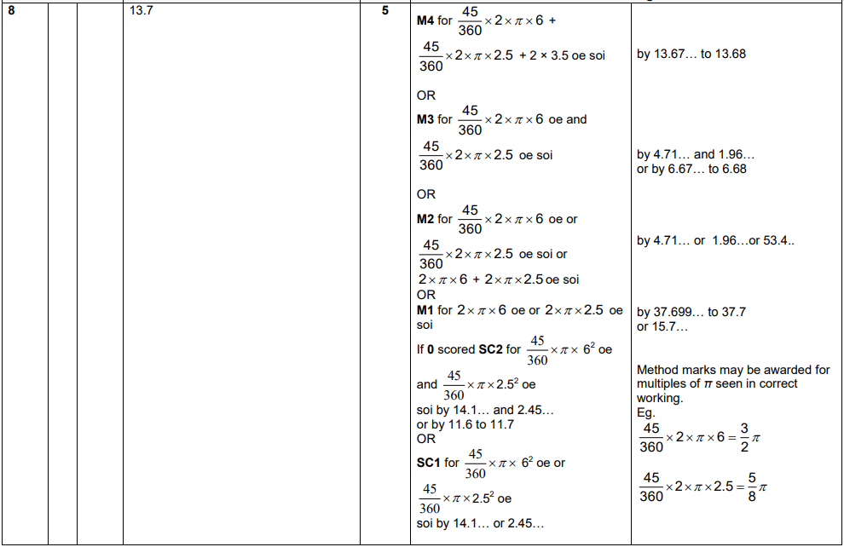

AQA GSCE – Tuesday 11 June 2019 – Paper 3 (Calculator) Higher Tier
28.
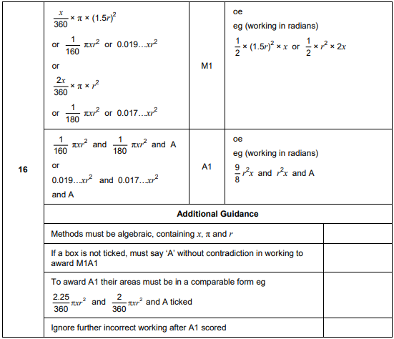
AQA GSCE – Thursday 2 November 2017 – Paper 1 (Non - Calculator) Higher Tier
29.
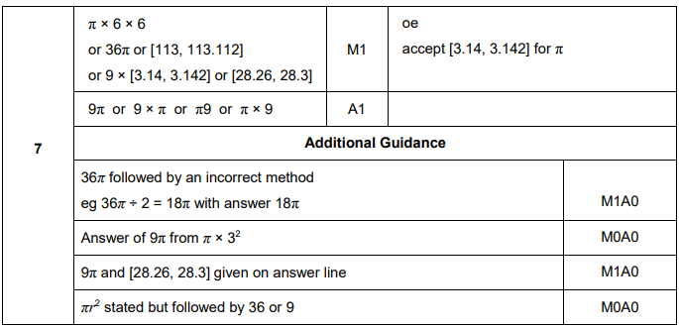
AQA GSCE – Thursday 6 November 2017 – Paper 2 (Calculator) Higher Tier
30.
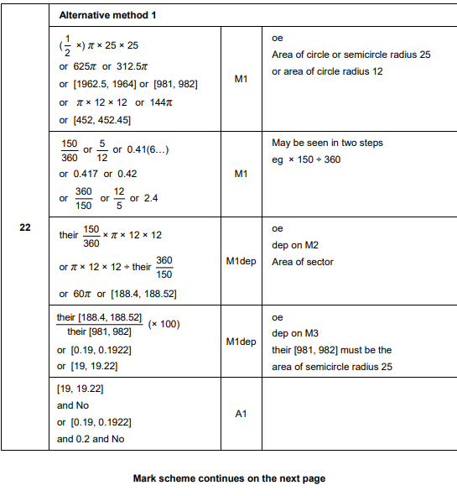
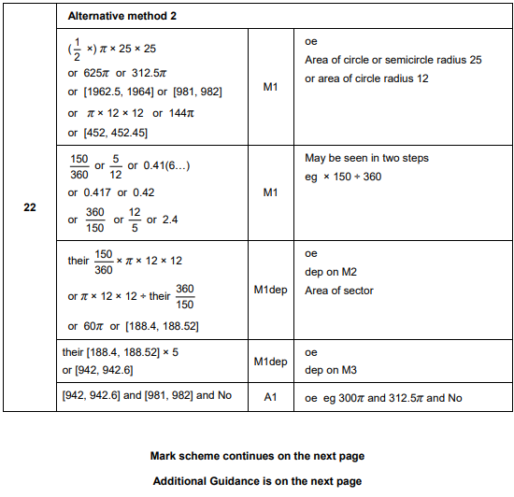
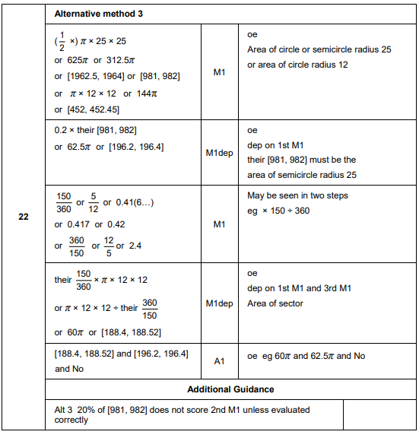
AQA GSCE – Thursday 8 June 2017 – Paper 2 (Calculator) Higher Tier
31.
